VSBE REPORTING MANUAL

Prepared by The Governor’s Office of Small, Minority & Women Business Affairs

July 1, 2023
Table of Contents

VSBE Program Overview 3
VSBE Certification - UPDATE 3
VSBE Liaisons 3
VSBE Compliance – UPDATE 4
VSBE Waivers NEW 4
VSBE Reporting Requirements 4
VSBE Data Collection 6
Backup Data 7
VSBE Supplemental Reporting Guidance - NEW 12
Contact Information 12

VSBE Program Overview

The Veteran-Owned Small Business Enterprise (VSBE) Program, enacted in 2010, requires participating agency/departments to spend a minimum of 1% of the total dollar value of their procurement contracts directly or indirectly with veteran-owned small businesses. Veteran business ownership status is determined by size standards adopted by the United States Small Business Administration in 13 C.F.R. 121.201 and whether at least 51% of the for-profit business is owned by one or more individuals who are veterans that control the management and daily operations of the business (§14-601 and added §14-606, State Finance & Procurement Article, Annotated Code of Maryland).

Effective October 1, 2018, legislative action assigned oversight of the VSBE Program to The Governor’s Office of Small, Minority & Women Business Affairs (GOSBA). Governance of the VSBE Program are found within:
- State Finance & Procurement Article §14-206 – §14-606
- Annotated Code of Maryland 21.11.14
All participating agencies and departments are required to submit annual performance data to GOSBA.

VSBE Certification - UPDATE

eMaryland Marketplace Advantage (eMMA) is the official system of record for the VSBE Database. As such, it is the only platform to use for verifying certified vendors in the VSBE Program. Do not use any other source to confirm certification in the state’s VSBE Program.

For guidance regarding the VSBE certification process, refer to the VSBE Program Guide found in the VSBE Toolkit.
https://gomdsmallbiz.maryland.gov/SiteAssets/Pages/Reporting-Tool-VSBE/VSBE%20Program%20Guide.png

VSBE Liaisons

Each participating agency/department is required to name a VSBE liaison in the administration of its VSBE Program. The VSBE liaison shall be a high-level employee reporting directly to a Secretary, Deputy Secretary, or head of procurement. The VSBE liaison serves as a member of the Procurement Review Group (PRG) and is responsible for coordinating outreach efforts to the veteran business community, reviewing agency contracting procedures to ensure compliance, assisting in the resolution of contracting issues, and submitting required VSBE Program reports and information. (COMAR 21.11.14.05).

VSBE Compliance - UPDATE

The contract owner should monitor and track VSBE compliance in accordance with the VSBE Forms - Attachment E - VSBE Utilization Affidavit and Prime/Subcontractor Participation Schedule submitted when the contract was awarded.
https://procurement.maryland.gov/wp-content/uploads/sites/12/2018/04/AttachmentE-VSBEForms.pdf

Each procurement agency shall furnish any other information or periodic reports requested by GOSBA in connection with VSBE procurements, or any other matters related to the administration, effectiveness, or continuation of the VSBE Program. (COMAR 21.11.14.06 & COMAR 21.11.14.11).

VSBE Waivers - NEW

Regulations regarding VSBE Program waivers were implemented in 2022 (COMAR 21.11.14.06). Follow the MBE & VSBE Goal Waiver Guidance when determining a MBE/VSBE waiver, determining good faith efforts, and universal language to use when notifying a vendor of a waiver determination.
https://procurement.maryland.gov/wp-content/uploads/sites/12/2022/11/BP-MBE_VSBE-Waiver-Guidance-v1-10.17.2022.pdf

Under this new guidance, each participating procurement unit is required to provide GOSBA with a copy of the waiver determination at the time it is made. The waiver determination shall be submitted to the following email box: vsbe.gosba@maryland.gov.

GOSBA prepares the statewide annual VSBE Waiver Data Report based on this information. If your unit granted any VSBE waivers during FY2023, but did not notify GOSBA, please send a copy of the waiver determination(s) no later than September 15, 2023.

VSBE Reporting Requirements

All participating agencies/departments are required to submit cumulative annual VSBE performance data and reports to GOSBA on or before the close of business on October 1st each year (COMAR 21.13.01.15).

GOSBA will provide the data collection templates, and all other pertinent information for reporting VSBE data. The VSBE report preparers shall rely upon the VSBE Reporting Toolkit, housed on GOSBA’s website. All reports and supporting backup data should be emailed to vsbereports.gosba@maryland.gov by the reporting deadline.

The latest VSBE Annual Report Templates will be available from GOSBA at the beginning of each reporting cycle. Only the latest template should be used to submit the VSBE Annual Report. This ensures that any changes or updates are captured.

GOSBA compiles the legislatively mandated VSBE Annual Report for publication to the governor, the legislators, and the public at large. If your unit does not comply, it is reported as “non-responsive.”

VSBE Annual Report Data

- Report both award and payment data utilizing your unit’s financial management platform (i.e. spreadsheets, FMIS, eMMA, Peoplesoft).

- Units utilizing ANSWERS shall report the data using the 700 series reports.

- Provide backup data for all figures reported. This must be auditable data.

- If contracts have both a VSBE prime and subcontractor, do not double count. Report the VSBE award and payment under the prime contractor only.

- Units utilizing ANSWERS must manually report the following VSBE awards and payments:

- PO change orders
- BPO change orders
- Credit card payments

- The completed VSBE Annual Report should be submitted in Excel format.

VSBE Outreach - NEW

Purchasing units are now required to make an evaluation of their VSBE Program’s outreach success. It shall include a brief description of efforts to engage VSBE prime and VSBE subcontractors (COMAR 21.11.14.06).

- The VSBE Outreach Form will be available from GOSBA on or before July 1st. Both quantitative and qualitative measures are needed for the VSBE Outreach Form.

- Two questions require a written narrative. “Not applicable” or “does not apply” are not acceptable responses in the response sections. Briefly explain what factors contributed to the overall VSBE Program performance being reported.

- The completed VSBE Program Outreach Form should be submitted in PDF format.

VSBE Data Collection
Agencies using the following 700 reports to collect AWARD and PAYMENT data from ANSWERS (https://net.md.gov/apps/answers/) must use the drop-down arrow to change the Report Type to “VET” where appropriate.

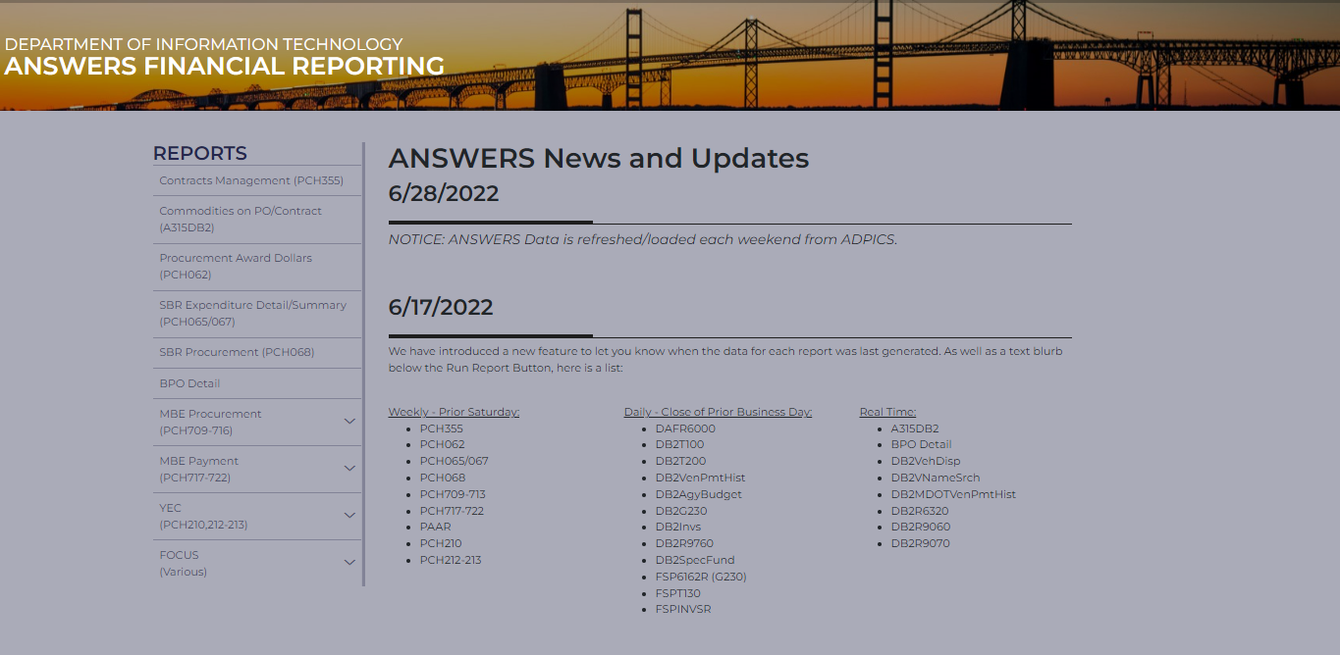

Awards:
a) PCHL709 (BPO/PO Change Orders from contracts awarded in prior fiscal years), no Vet Flag must determine manually
b) PCHL710 (Contract Awards Detail) run by award date with Vet Flag
c) PCHL717 (VSBE Prime Payments by Direct Voucher; no BPO/PO)* with Vet Flag
d) PCHL720 (VSBE Subcontract Awards) run by award date with Vet Flag
Outside of ANSWERS, you must report
e) Manually tracked Credit Card (PCHL 721) payments*

Payments:
a) PCHL717 (VSBE Prime Payments by Direct Voucher; no BPO/PO)* with Vet Flag
b) PCHL718 (VSBE Prime Voucher Payments made from BPO/PO) with Vet Flag
c) PCHL719 (VSBE Subcontractor Payments) with Vet Flag
Outside of ANSWERS, you must report:
d) Manually tracked Credit Card/(PCHL 721) payments*

* - PCHL 717 and Credit Card Payments are reported as both payments and awards.

FMIS CHEAT SHEET

AWARDS = ANSWER reports 709, 710, 717, 720 & 721 OR VIEW DIRECT A30USB11

PAYMENTS = ANSWER reports 717, 718, 719 & 721 OR VIEW DIRECT A30USB11

Reminder: Direct Vouchers and P-card purchases* are reported as both AWARDS and PAYMENTS.

*With the exception of control agency/department statewide contracts

Tips
The purpose of reporting is to provide evidence of the State’s commitment to procuring goods and services from certified VSBE vendors. Non-procurement items should not be included. (Refer to COMAR 21.01.03.01 for items that are exempt from procurement reporting.)

For a complete list of exclusions, visit and download the GAD List Exclusion Definitions. https://gomdsmallbiz.maryland.gov/Documents/MBE_Toolkit/GADLISTEXCLUSIONDEFINITIONS0116.pdf
The use of non-delegated Statewide Contracts is not reportable as awards; however, payments made on these contracts are reportable in the payments table on the VSBE Annual Report. (Rule of thumb: Awards – do not include awards made from Statewide Contracts. Payments – report all procurement payments, including payments on Statewide contracts.)

Backup Data

- 700 Series and Credit Card Reports should be scrubbed to remove all non-reportable items and no negative numbers.

- All original and scrubbed reports should be complied to one Excel Workbook on different tabs with VSBE totals clearly identified.

- Both the VSBE Annual Report Data Form and the VSBE Program Outreach Form should be emailed in together along with all required backup data.

VSBE Annual Reporting Templates

The VSBE Annual Report Template is located in the VSBE Toolkit on GOSBA’s website.

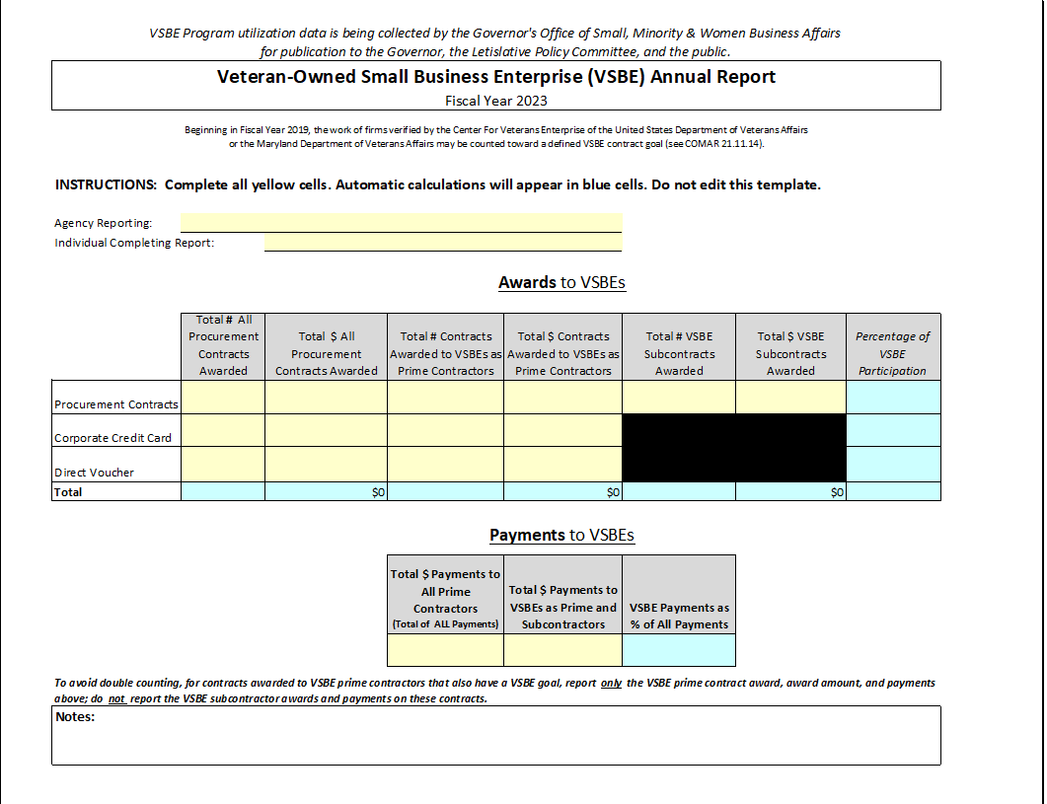

- All AWARDS columns require data for three different award types: Regular Procurement Contracts, Corporate Credit Card, and Direct Voucher Awards.
- The yellow cells indicate that data must be added, blue cells indicate that data is calculated, and these cells are protected.

Enter award data as follows:

Row 7: Enter agency/department name
Row 8: Enter report preparers’ name
Awards Column B: Count the total agency procurements for each award type and place the # here.
Awards Column C: Add the $ amounts of total agency procurements for each award type and place amount here
Award Column D: Count the total Contracts awarded to VSBE Primes for each award type and place the # here
Awards Column E: Add the $ amounts of total procurements awarded to VSBE Primes for each award time and place amount here
Awards Column F: Count the total procurements awarded to VSBE Subcontractors for each award type and place the # here
Awards Column G: Add the $ amounts of total procurements awarded to VSBE Subcontractors for each award type and place amount here

The VSBE participation % is calculated automatically.

Enter payment data as follows:

PAYMENT columns only require data for two cells
Payment Cell D21: Total $ amounts paid to all Prime Contractors
Payment Cell E21: Total $ amounts paid to VSBE Prime and Subcontractors

The VSBE payment % is calculated automatically.

The new VSBE Program Outreach Form is located in the VSBE Toolkit on GOSBA’s website.

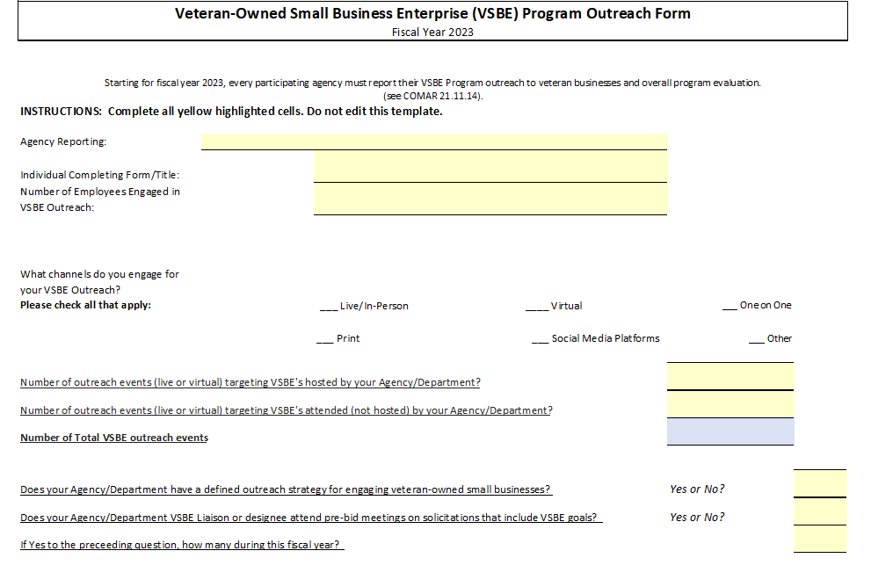
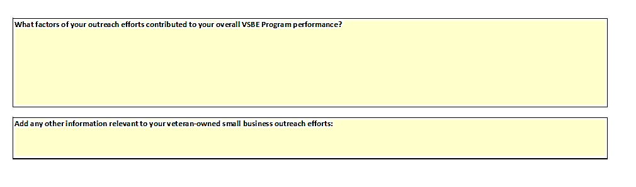
- Both quantitative and qualitative information is needed to complete this form.

- The yellow cells indicate that data and narratives must be manually added, blue cells indicate that data is calculated, and these cells are protected.

- Due to this outreach information being new for reporting, we strongly encourage to be as descriptive as possible in the narrative sections, so we understand the basis of your reply.

- To assist with evaluating the success of your VSBE Program. GOSBA has defined some areas to consider. If additional recommendations would like to be made, they can be emailed to danielle.davis2@maryland.gov.

VSBE Supplemental Reporting Guidance

The purpose of the supplemental guidance is to assist where data totals are to be reported.

ANSWERS
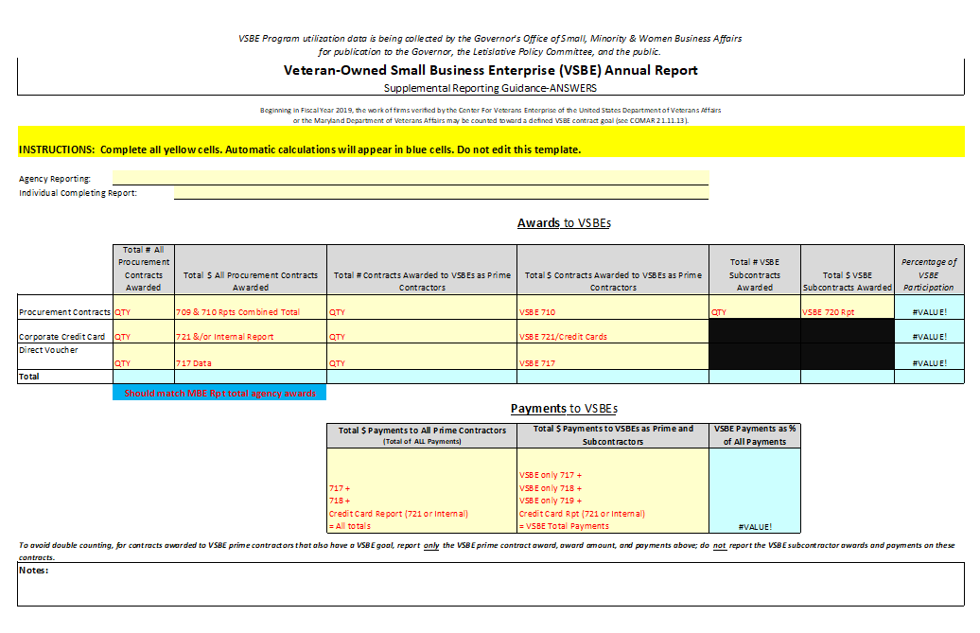

Non-ANSWERS

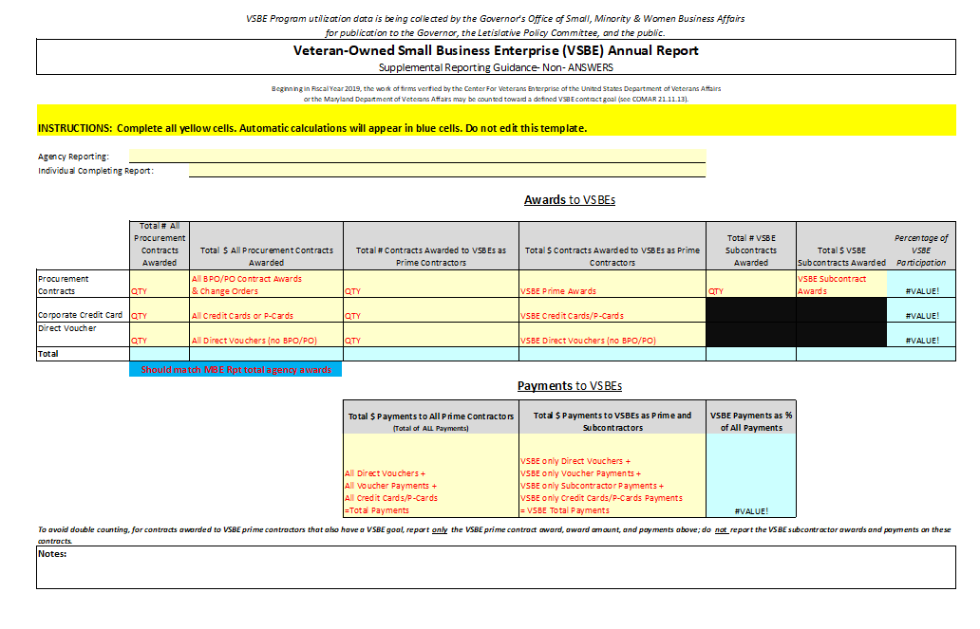

Contact Information

Completed annual reports and backup data should be emailed to GOSBA by October 1st at vsbereports.gosba@maryland.gov.

General questions about the VSBE Program or reporting should be directed to VSBE Compliance Manager, Danielle Davis by phone to 443-346-0717 or via email to
danielle.davis2@maryland.gov.

